***Computer Organization***

**Lab 7a Report**

***Names:***

**عبد الرحمن إسماعيل محمد حسن (22010866)**

**نور الدين اكرم السيد كامل سيف (22011309)**

**Introduction**

This project demonstrates the use of an IR remote control and an IR sensor to control the blinking rate of an LED.

**Implementation Setup**

* Arduino UNO microcontroller board.
* One red LED.
* One resistor (1 kΩ) to limit current to the LED.
* Remote control to send IR signals.
* IR sensor (1838) to receive IR signals.
* Breadboard for building the circuit.
* Jumper wires for circuit connections.
* Arduino IDE for programming the microcontroller.

**Implementation Details**

* The Arduino continuously reads the digital input from the IR sensor.
* 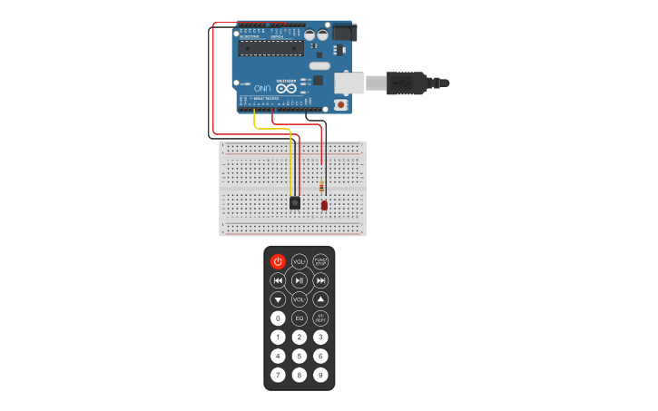The Arduino then checks if a signal is received, if so, the Arduino decodes it.
* The decoded signal is then used to determine which button was pressed and set the corresponding blinking rate of the LED.

**Circuit Layout Diagram**

**Circuit Schematic Diagram**

